CSE3012/CSE384: Database Design Lab

**Worksheet 3**: Database Connection



**Task 1**

Create a “form.html” file and design a simple text form with text boxes. To achieve this, write the following code:

<html>

<body>

<h1>A simple example page to insert some data in to a MySQL database using PHP</h1>

<form action="insert.php" method="post">

First name: <input type="text" name="fname" /><br><br>

Last name: <input type="text" name="lname" /><br><br>

<input type="submit" />

</form>

</body>

</html>

Your form will look like this:

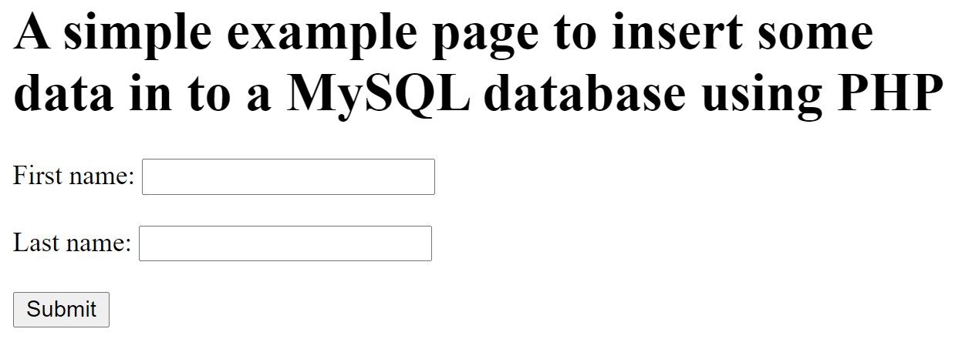

**Task 2**

1. Add another text box for ID in Task 1.
2. Change First name to Name
3. Change Last name to CGPA. Change the input type to number. Specify max and min and step for allowing decimal values. (<https://www.w3schools.com/tags/att_input_type_number.asp> )

**Task 3**Open PhPmyAdmin (localhost/phpmyadmin) and create a database. In that database, you should have a table named STUDENT with the following attributes: ID, Name and CGPA.

**Task 4**

Create a “insert.php” file. Now use the approach given below to connect to your database.

<?php  
$servername = "localhost";  
$username = "username";  
$password = "password";

$dbname= "dbname";  
  
// Create connection  
$conn = new mysqli($servername, $username, $password, $dbname);  
  
// Check connection  
if ($conn->connect_error) {  
    die("Connection failed: " . $conn->connect_error);  
}   
echo "Connected successfully";  
?>

**Task 5**

1. Write the code to insert data manually into the database in the “insert.php” file

$sql = "INSERT INTO STUDENT VALUES ('01902192', 'Harry', 3.8)";

1. Make the necessary changes in insert.php according to <https://www.w3schools.com/php/php_mysql_insert.asp>

**Task 6**

Now change your code to insert values from the form into the database. The data in each text box/input button can be accessed using $_POST[name].

E.g. $sql = "INSERT INTO Student VALUES ('$_POST[id]' ,$_POST[cgpa])";

**Examples**

For selecting data from database: <https://www.w3schools.com/php/php_mysql_select.asp>

For deleting data from database: <https://www.w3schools.com/php/php_mysql_delete.asp>

For updating data in database: <https://www.w3schools.com/php/php_mysql_update.asp>